Volatility correlation: USDJPY and EURGBP
Method 25 / daily |log returns| / rho_vol / Alpari D1 full available history (realized deferred)

Study setup
Logical pair: USDJPY , EURGBP
Broker symbols: USDJPY_i , EURGBP_i
Snapshot: 2026-11-03_majors_alpari_D1
Timeframe: D1
Matched return window: 1999-01-06 to 2026-11-02 (UTC bar dates)
Matched return count n: 7181
Dropped unfinished last bar dated 2026-11-03 UTC after a tick-volume check against the prior complete day.
Statistic: rho_vol = Corr(|log return_L|, |log return_R|)
rho_realized: not computed (no intraday buckets in this snapshot)
Complete matched rows (Excel): USDJPY-EURGBP_Vol_D1.xlsx
Complete matched rows (HTML table): USDJPY-EURGBP_Vol_D1_data.html

Method carried forward
Volatility correlation rho_vol = Corr(|x_t|, |y_t|) measures whether absolute daily log returns of close move together in size, regardless of sign. Quotes are not inverted. Same-sample signed Pearson r is a side check. The formula sheet also defines within-day realized correlation rho_realized,d from intraday buckets; this v001 uses the Alpari D1 snapshot only, so rho_realized is not computed (no intraday buckets). This is not causation and not a trading signal.

Results (headline)
rho_vol: 0.177551
Pearson r (signed): -0.127992
mean |USDJPY|: 0.00444984
mean |EURGBP|: 0.00354098
rho_realized: n/a (D1-only snapshot)

Conclusion
Headline rho_vol for USDJPY and EURGBP: 0.1776. Signed Pearson r = -0.1280. Mean |return|: 0.004450 (USDJPY), 0.003541 (EURGBP). rho_realized not computed (D1 snapshot has no intraday buckets). This is absolute-move co-movement, not a trading signal.

Charts
Daily closes

Daily log returns

Absolute returns scatter
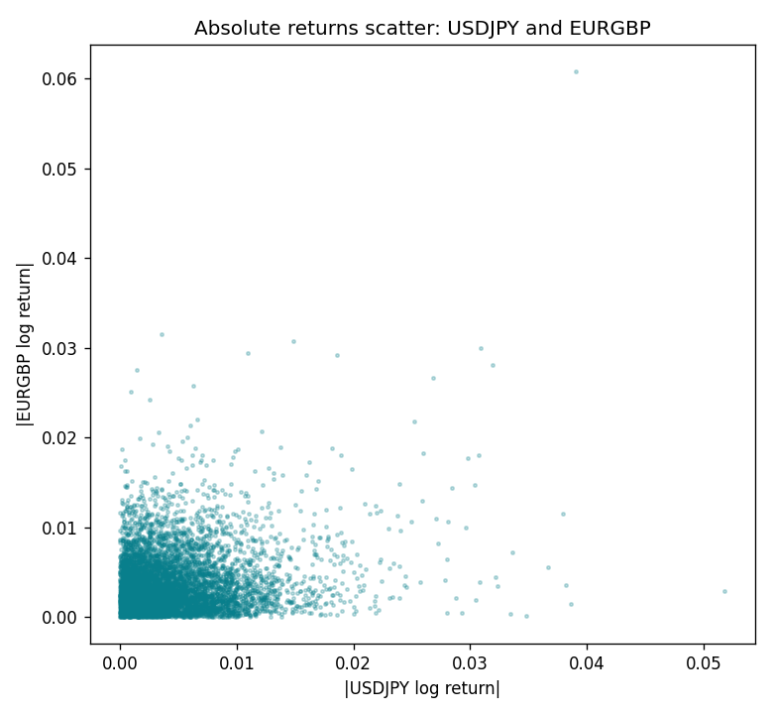

Data report
Matched rows are in the sibling Excel workbook named USDJPY-EURGBP_Vol_D1.xlsx. Embedding all rows as a Word table is impractical; this file holds column summaries and the first and last 15 matched rows.
Columns: time, USDJPY_open, EURGBP_open, USDJPY_high, EURGBP_high, USDJPY_low, EURGBP_low, USDJPY_close, EURGBP_close, USDJPY_tick_volume, EURGBP_tick_volume, USDJPY_spread, EURGBP_spread, USDJPY_real_volume, EURGBP_real_volume, USDJPY_log_return, EURGBP_log_return, USDJPY_abs_return, EURGBP_abs_return
Column summaries (matched calculation rows)
column | count | mean | std | min | 25% | 50% | 75% | max
USDJPY_open | 7181 | 113.80773 | 19.228846 | 75.693 | 104.38 | 110.98 | 120.71 | 163.824
EURGBP_open | 7181 | 0.78701429 | 0.09663819 | 0.5734 | 0.6877 | 0.83392 | 0.86523 | 0.9769
USDJPY_high | 7181 | 114.30513 | 19.290536 | 76.001 | 104.865 | 111.439 | 121.27 | 163.978
EURGBP_high | 7181 | 0.79009197 | 0.09701345 | 0.5789 | 0.6897 | 0.83701 | 0.8681 | 0.9799
USDJPY_low | 7181 | 113.28458 | 19.156841 | 75.402 | 103.87 | 110.53 | 120.172 | 163.628
EURGBP_low | 7181 | 0.78431381 | 0.09645598 | 0.5682 | 0.6857 | 0.83166 | 0.86287 | 0.9661
USDJPY_close | 7181 | 113.82069 | 19.244339 | 75.811 | 104.38 | 111.015 | 120.695 | 163.851
EURGBP_close | 7181 | 0.78705735 | 0.09663932 | 0.5735 | 0.6878 | 0.83401 | 0.86539 | 0.977
USDJPY_tick_volume | 7181 | 106398.86 | 179473.16 | 149 | 9958 | 53207 | 92916 | 1803508
EURGBP_tick_volume | 7181 | 87156.048 | 145513.65 | 154 | 6593 | 44384 | 81451 | 1424684
USDJPY_spread | 7181 | 20.250104 | 17.60648 | 0 | 6 | 11 | 30 | 50
EURGBP_spread | 7181 | 21.316669 | 19.115948 | 0 | 4 | 13 | 40 | 50
USDJPY_real_volume | 7181 | 3.4800425e+10 | 1.6097887e+11 | 0 | 0 | 0 | 0 | 3.8834203e+12
EURGBP_real_volume | 7181 | 2.788005e+10 | 1.3523257e+11 | 0 | 0 | 0 | 0 | 3.5726265e+12
USDJPY_log_return | 7181 | 4.847e-05 | 0.00620794 | -0.03908203 | -0.00320533 | 0.00011473 | 0.00340924 | 0.05184024
EURGBP_log_return | 7181 | 2.133e-05 | 0.00487349 | -0.03067367 | -0.00262366 | -0.00010035 | 0.00255918 | 0.06075387
USDJPY_abs_return | 7181 | 0.00444984 | 0.00432862 | 0 | 0.00143267 | 0.00330805 | 0.00619497 | 0.05184024
EURGBP_abs_return | 7181 | 0.00354098 | 0.0033483 | 0 | 0.00119304 | 0.00260332 | 0.00486046 | 0.06075387
First 15 matched rows (selected columns)
time | USDJPY_log_return | EURGBP_log_return | USDJPY_abs_return | EURGBP_abs_return
1999-01-06 | 0.0075660159 | -0.013303338 | 0.0075660159 | 0.013303338
1999-01-07 | -0.012851583 | 0.011051402 | 0.012851583 | 0.011051402
1999-01-08 | -0.0047719894 | -0.004943862 | 0.0047719894 | 0.004943862
1999-01-11 | -0.016195423 | -0.0012752393 | 0.016195423 | 0.0012752393
1999-01-12 | 0.032310364 | 0.0033970309 | 0.032310364 | 0.0033970309
1999-01-13 | 0.0081373171 | 0.00042381861 | 0.0081373171 | 0.00042381861
1999-01-14 | 0 | -0.0019793588 | 0 | 0.0019793588
1999-01-15 | 0.0055343401 | -0.0076715819 | 0.0055343401 | 0.0076715819
1999-01-18 | 8.7600193e-05 | 0.00071280921 | 8.7600193e-05 | 0.00071280921
1999-01-19 | -0.0056219403 | -0.0014261269 | 0.0056219403 | 0.0014261269
1999-01-20 | -0.0053879917 | 0.0019960086 | 0.0053879917 | 0.0019960086
1999-01-21 | 0.0084664056 | -0.00071240297 | 0.0084664056 | 0.00071240297
1999-01-22 | 0.0060412564 | -0.0017118406 | 0.0060412564 | 0.0017118406
1999-01-25 | -0.0073594164 | -0.0054402425 | 0.0073594164 | 0.0054402425
1999-01-26 | 0.0012303367 | -0.00057438255 | 0.0012303367 | 0.00057438255
Last 15 matched rows (selected columns)
time | USDJPY_log_return | EURGBP_log_return | USDJPY_abs_return | EURGBP_abs_return
2026-10-13 | -0.0018932826 | 0.00020130374 | 0.0018932826 | 0.00020130374
2026-10-14 | 7.5800166e-05 | 0.0011241873 | 7.5800166e-05 | 0.0011241873
2026-10-15 | -0.0018524319 | -0.00087557391 | 0.0018524319 | 0.00087557391
2026-10-16 | -0.00037976126 | -0.0020380844 | 0.00037976126 | 0.0020380844
2026-10-19 | 0.0034946841 | -0.00056950988 | 0.0034946841 | 0.00056950988
2026-10-20 | -0.0022546642 | -0.0035906254 | 0.0022546642 | 0.0035906254
2026-10-21 | -0.00032883504 | -0.00140647 | 0.00032883504 | 0.00140647
2026-10-22 | -0.0085942669 | -0.0018743924 | 0.0085942669 | 0.0018743924
2026-10-23 | 0.00035080446 | 0.00082421033 | 0.00035080446 | 0.00082421033
2026-10-26 | 0.0041238746 | 0.00013133309 | 0.0041238746 | 0.00013133309
2026-10-27 | 0.0027651658 | -0.0019957343 | 0.0027651658 | 0.0019957343
2026-10-28 | -0.00095679538 | 0.00066967224 | 0.00095679538 | 0.00066967224
2026-10-29 | -0.00038043789 | -0.0011722209 | 0.00038043789 | 0.0011722209
2026-10-30 | -0.0010596481 | -0.0024205543 | 0.0010596481 | 0.0024205543
2026-11-02 | 0.0026438521 | 0.00089940465 | 0.0026438521 | 0.00089940465

